100WLED Spot Light with LED ring

operating instruction
（RDM、color display、Touch operation）

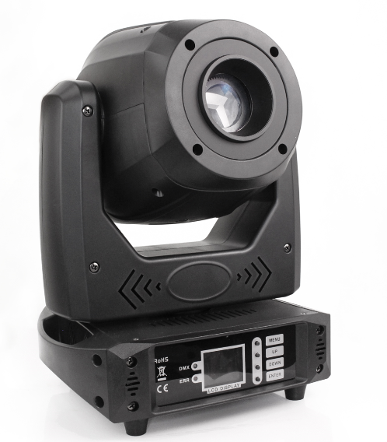

User’s Manual

Chapter 1 Installation and attention

1.1 Maintenance
- To reduce the risk of electrical shock or fire, do not expose this unit to rain or moisture.
- Intermittently using will extend this item’s service life.
- Please clear the fan , fan net , and optical lens in order to keep good working condition.
- Do not use the alcohol or any other organic solvent to wipe the shell.

1.2 Statement
The product performance and packaging has been tested before shipping. All users should strictly comply with the warning and operating instructions as stated. Any misuse and damage as a result of use outside of the guidelines herein will result in a voided warranty. Any fault or problem caused by neglecting the manual is will not be covered by warranty.
Note: All information is subject to change without prior notice.

1.3 Safety Precaution
- In order to guarantee the product’s life, please don’t put it in the damp places or even the environment over 140 degrees.
- Always mount this unit in safe and stable matter.
- Install or dismantle should be performed by a professional engineer.
- Please restart 20 minutes later after turning off light , until full-cooling. Frequent switching will reduce the life span of lamps and bulbs; intermittent using will improve the life of bulbs and lamps.
- In order to make sure the product is used correctly, please read the Manual carefully.

1.4 Product Instruction
- LED: 1pcs * 100W White LED
- Channel mode: 14 DMX512 Channel
- Pan scan：540°(16bit) Electric correction
- Tilt scan：270° (16bit) Electric correction
- Color wheel: 7color + white
- Gobo: Fixed Gobo 7 + white, Rotation Gobo 6 + white
- Prism: 3 prism
- 0-100% mechanical dimming, mechanical dimming and free dimming available.
- Power Input: 100-240V，50/60Hz
- Power Dissipation：200W
- IP level :IP20

1.5 Cable connection（DMX）
Use a cable conforming to specifications EIA RS-485: 2-pole twisted, shielded, 120Ohm characteristic impedance, 22-24 AWG, low capacity. Do not use microphone cable or other cable with characteristics differing from those specified. The end connections must be made using XLR type 3 or 5-pin male/female connectors. A terminating plug must be inserted into the last projector with a resistance of 120Ohm (minimum 1/4 W) between terminals 2 and 3.
IMPORTANT: The wires must not make contact with each other or with the metal casing of the connectors. The casing itself must be connected to the shield braid and to pin 1 of the connectors.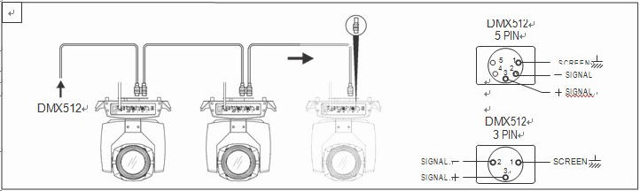
Figure 1 DMX Cable connection

1.6 Rigging (Optional)
This equipment can be positioned and fixed by clamp in every direction of the stage. Locking system makes it easy to fasten to the bracket.
Attention! Two clamps is needed to attach the equipment. Every clamp is locked by fastener of 1/4 turn kind. Fastener can only be locked clockwise.
Attention! Fasten a safety cable to the additional hole of side aluminum piece. The secondary accessory can not hang on the delivery handle. Nip the equipment on bracket.
- Check if rigging clamp (not including the one inside) damaged or not? Must be able to withstand ten times weight of the equipment. Make sure the architecture can withstand ten times weight as all the equipments, clamps, wirings and other additional fixtures.
- Screws for clamping must be fixed firmly. Take one M12 screw (Grade 8.8 or higher) to clamp bracket, and then screw the nuts.
- Level the two hanging points at the bottom of clamp. Insert fastener to the bottom, lock the two levers by 1/4 rotating clockwise; then install another clamp.
- Install on safety cable which withstands at least ten times weight as equipment. Terminal of the accessory is designed for clamps.
- Make sure pan/tilt lock unlocked or not. Keep the distance more than 1M from equipment to flammable material or lighting source.
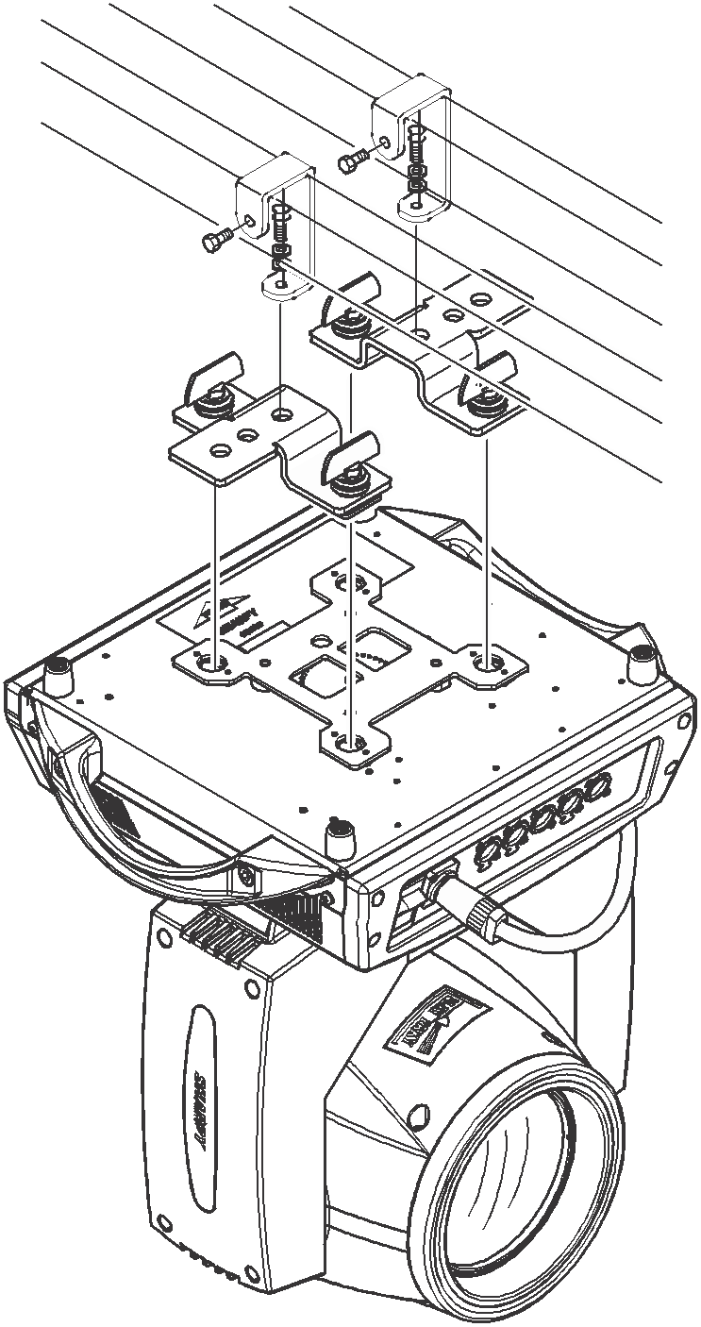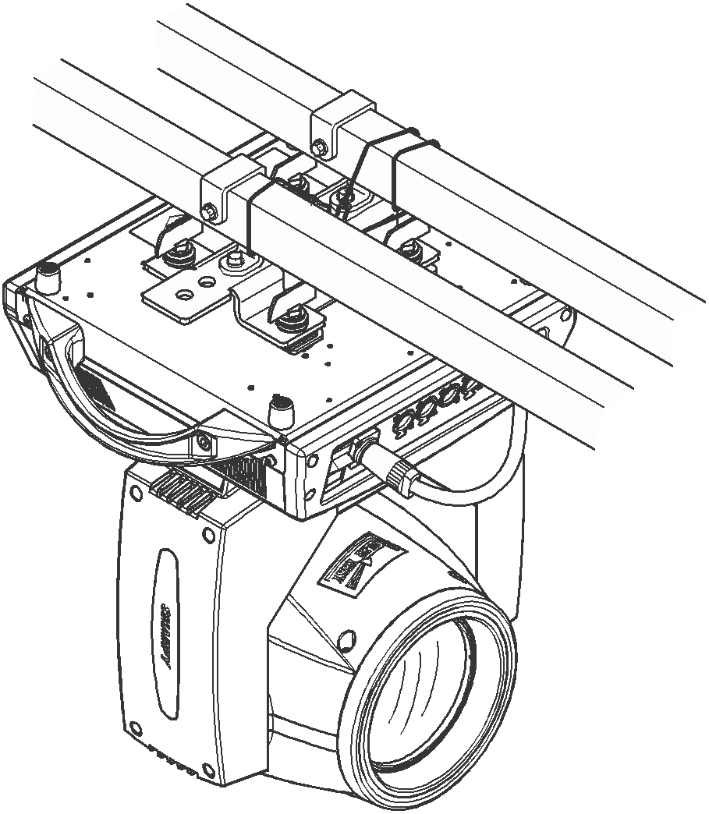
Figure 2 Installation
Chapter 2. Menu Operation

Within the main menu you can enter 6 sub menus, shown in Figure 6. Sub menus include class of parameter and status:
- ADDR：Set light DMX address.
- MODE：Set light work mode, master or slave mode when in auto run mode.
- DISP： Set display parameter, eg. select language.
- SCENE：Used for test light, modify DMX channel data to test function， the corresponding function of reference channel function table.
- ADVA：Set light running parameter.
- STAT：view light current status.

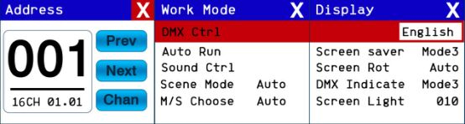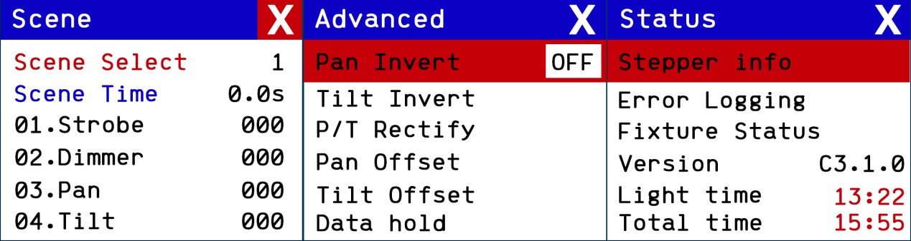

Chapter 3 Channel description

Channel table
CHANNEL2 | NAME | VALUE | DEFIE
CH1 | Strobe | 0-3 | Dark
 |  | 4-127 | Slow strobe to fast strobe
 |  | 128-191 | Slow strobe to fast strobe(mode 2)
 |  | 192-251 | Slow strobe to fast strobe
 |  | 252-255 | White
CH2 | Dimmer | 0-255 | 0-100% Dimmer
CH3 | PAN | 0-255 | 0-540
CH4 | TITL | 0-255 | 0-270
CH5 | XY speed | 0-255 | fast to slow
CH6 | Color | 0-7 | White
 |  | 8-15 | White + Color1
 |  | 16-23 | Color1
 |  | 24-31 | Color1 + Color2
 |  | 32-39 | Color2
 |  | 40-47 | Color2 + Color3
 |  | 48-55 | Color3
 |  | 56-63 | Color3 + Color4
 |  | 64-71 | Color4
 |  | 72-79 | Color4 + Color5
 |  | 80-87 | Color5
 |  | 88-95 | Color5 + Color6
 |  | 96-103 | Color6
 |  | 104-111 | Color6 + Color7
 |  | 112-119 | Color7
 |  | 120-127 | Color7 + White
 |  | 128-190 | Rotate forward (fast to slow)
 |  | 191-192 | Stop
 |  | 193-255 | Rotate reverse (slow to fast)
CH7 | Gobo | 0-9 | White
 |  | 10-19 | GOBO1
 |  | 20-29 | GOBO2
 |  | 30-39 | GOBO3
 |  | 40-49 | GOBO4
 |  | 50-59 | GOBO5
 |  | 60-69 | GOBO6
 |  | 70-79 | GOBO7
 |  | 80-84 | Shake slow to fast GOBO1
 |  | 85-89 | Shake slow to fast GOBO2
 |  | 90-94 | Shake slow to fast GOBO3
 |  | 95-99 | Shake slow to fast GOBO4
 |  | 100-104 | Shake slow to fast GOBO5
 |  | 105-109 | Shake slow to fast GOBO6
 |  | 110-127 | Shake slow to fast GOBO7
 |  | 128-190 | Rotate forward (fast to slow)
 |  | 191-192 | Stop
 |  | 193-255 | Rotate reverse (slow to fast)
CH8 | Revolve Gobo | 0-9 | White
 |  | 10-19 | GOBO1
 |  | 20-29 | GOBO2
 |  | 30-39 | GOBO3
 |  | 40-49 | GOBO4
 |  | 50-59 | GOBO5
 |  | 60-69 | GOBO6
 |  | 70-79 | Shake slow to fast GOBO1
 |  | 80-89 | Shake slow to fast GOBO2
 |  | 90-99 | Shake slow to fast GOBO3
 |  | 100-109 | Shake slow to fast GOBO4
 |  | 110-119 | Shake slow to fast GOBO5
 |  | 120-127 | Shake slow to fast GOBO6
 |  | 128-190 | Rotate forward (fast to slow)
 |  | 191-192 | Stop
 |  | 193-255 | Rotate reverse (slow to fast)
CH9 | Gobo ROT | 0-127 | 0-400
 |  | 128-190 | Rotate forward (fast to slow)
 |  | 191-192 | Stop
 |  | 193-255 | Rotate reverse (slow to fast)
CH10 | Prism 1 Rot | 0-19 | None
 |  | 20-63 | Insert prism
 |  | 64-255 | Rotate reverse (slow to fast)
CH11 | Focus | 0-255 | far to near
CH12 | PAN Fine | 0-255 | 0-2
CH13 | TILT Fine | 0-255 | 0-1
CH14 | Auxiliary light strobe | 0-10 | turn off
 |  | 11-249 | Slow to fast strobe
 |  | 250-255 | Opening
CH15 | Auxiliary light effect | 0-3 | none
 |  | 4-7 | R
 |  | 8-11 | G
 |  | 12-15 | B
 |  | 16-19 | R+G
 |  | 20-23 | G+B
 |  | 24-27 | R+B
 |  | 28-31 | R+G+B
 |  | 32-59 | Mixed color horse 1
 |  | 60-95 | Mixed color horse 2
 |  | 96-127 | Background horse
 |  | 128-149 | Slow to fast gradient
 |  | 150-199 | Slow to fast transition color
 |  | 200-255 | Slow to fast transition color
CH16 | Features | 0-25 | None
 |  | 26-76 | Reset for more than 3 seconds XY
 |  | 77-127 | Reset effect motor for more than 4 seconds
 |  | 128-255 | Reset all over 5 seconds

