LED stage lighting equipment instruction manual

100W LED module beam moving head light

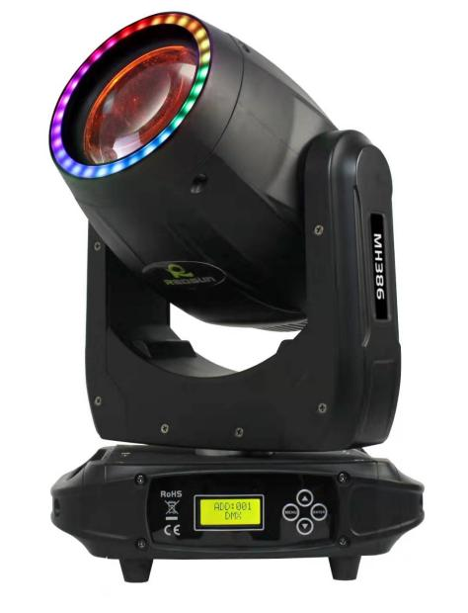

Please read the instruction manual carefully before use

Compared with LED moving head light and traditional par light, LED moving head light has more rich color effects.The color mixing effect is more abundant, the color mixing effect of the three primary colors of the led has risen to 16,700,000,LED moving head light
别：按 The usage conditions are divided into two categories, one is commercial lighting, also
known as floodlights.
Mainly play the role of lighting, high-power LED lights, LED lights are usually used as a single color and small volume light.
被使 Used in shopping malls, hotels, hotels, fountain plazas, etc.。
The colors of LED lights are red, green, blue, and white, and they are often used in stage performances, wedding ceremonies, exhibitions and conference venues.

主要扮
- Safety Instruction
- Please keep this User Guide for future consultation.If you sell the unit to another user,be sure that they also receive this instruction booklet
- Unpack and check carefully there is no transportation damage before using the unit.
- Before operating,ensure that the voltage and frequency of power supply match the power requirements of the unit
- It’s important to ground the yellow/green conductor to earth in order to avoid electric shock.
- The unit is for indoor use only.Use only in a dry location
- The unit must be installed in a location with adequate ventilation,at least 50cm from adjacent surfaces.Be sure that no ventilation slots are blocked
- Disconnect main power before replacement or servicing.
- Make sure there is no flammable materials close to the unit while operating as it is fire hazard.
- Use safety cable when fixes this unit.Don’t handle the unit by taking its head only,But always by taking its base.
- Maximum ambient temperature is ta:40℃. Don't operate it where the temperature is higher than this.
- Unit surface temperature may reach up to 85℃.Dont touch the housing bare-hand during its operation.Turn off the power and allow about 15 minutes for the unit to cool down before replacing or serving.

10 | Prism | 0-30 | Prism cut
 |  | 31-63 | Prism cut out
 |  | 64-255 | Slow to fast rotation clockwise
11 | focusing | 0-255 | Linear focus
12 | Auxiliary light dimming | 0-255 | 0%-100% dimming
13 | Auxiliary light strobe | 0-3 | Lights off
 |  | 4-255 | Synchronous strobe
14 | Auxiliary light effect | 0-51 | Built-in colors
 |  | 52-55 | Effect 1
 |  | 56-59 | Effect 2
 |  | … | One effect for every 4 numbers
 |  | 252-255 | Effect 51
15 | Effect speed | 0-255 | From slow to fast
16 | Reset | 0-199 | Invalid area
 |  | 200-205 | Reset all
 |  | 206-255 | Invalid area

Technical Parameters:
Rated Power: 120W
Rated Voltage: AC100V-240V 50/60Hz
Light Source: 1x100W LED+30x0.2W RGB 3in1(light strip)
Color Wheel: 17+white
Pattern Wheel: 15+white
Prism Wheel: 6+12 facet rotation prism
Channels: 16/18CH
Zoom: Yes
Strobe: Yes
X axis: 540°
Y axis: 270°
Control Mode: DMX512, master-slave, self-propelled, voice control
Dimming: 0-100% linear dimming
Product Weight: 7.5kgs
Gross Weight: 9kgs

 |  | 43-46 | Pattern 11
 |  | 47-50 | Pattern 12
 |  | 51-54 | Pattern 13
 |  | 55-58 | Pattern 14
 |  | 59-62 | Pattern 15
 |  | 63-66 | Pattern 16
 |  | 67-70 | Pattern 17
 |  | 71-77 | Pattern 1 jitters from slow to fast
 |  | 78-84 | Pattern 2 jitters from slow to fast
 |  | 85-91 | Pattern 3 jitters from slow to fast
 |  | 92-98 | Pattern 4 jitters from slow to fast
 |  | 99-105 | Pattern 5 jitters from slow to fast
 |  | 106-112 | Pattern 6 jitters from slow to fast
 |  | 113-119 | Pattern 7 jitters from slow to fast
 |  | 120-126 | Pattern 8 jitters from slow to fast
 |  | 127-133 | Pattern 9 jitters from slow to fast
 |  | 134-140 | Pattern 10 jitters from slow to fast
 |  | 141-147 | Pattern 11 jitters from slow to fast
 |  | 148-154 | Pattern 12 jitters from slow to fast
 |  | 155-161 | Pattern 13 jitters from slow to fast
 |  | 162-168 | Pattern 14 jitters from slow to fast
 |  | 169-175 | Pattern 15 jitters from slow to fast
 |  | 176-182 | Pattern 16 jitters from slow to fast
 |  | 183-189 | Pattern 17 jitters from slow to fast
 |  | 190-221 | Flowing water counterclockwise from fast to slow
 |  | 222-223 | Stop water flow
 |  | 224-255 | Flow clockwise from slow to fast

One: Menu
Serial number | menu | Specific instructions
First interface | ADD：001  DMX | Address code and operating mode
1 | Address | Address code setting (1-512)
2 | Run Mode： | Run mode (DMX/Auto Run/Sound)
3 | Chanel | Channel mode (16CH)
4 | Invert-X | X axis reverse
5 | Invert-Y | Y axis reverse
6 | Pan | X axis starting position calibration
7 | Title | Y-axis starting position calibration
8 | Focus | Focusing start position calibration
10 | Color | Color wheel start position calibration
11 | Gobo | Calibration of the starting position of the fixed chart
12 | Prism | Prism start position calibration
13 | Dimmer | Maximum power setting
14 | Bklight | Backlight time setting
15 | Sound | Sound sensitivity setting
16 | Default？ | Whether to restore the default value
17 | Reset？ | Whether to reset
18 | Version | Version Information

Two: Channel table
Serial number | Channel function | Numerical value | description
1 | X | 0-255 | 0--540°
2 | X fine-tuning | 0-255 | X axis 16bit
3 | Y | 0-255 | 0--270°
4 | Y fine-tuning | 0-255 | Y axis 16bit
5 | XY speed regulation | 0-255 | Fast-slow
6 | Dimming | 0-255 | 0%-100% dimming
7 | Strobe | 0-3 | invalid
 |  | 4-99 | Synchronous strobe
 |  | 100-149 | Pulse strobe
 |  | 150-199 | Strobe
 |  | 200-249 | Random strobe
 |  | 250-255 | Light up
8 | colour | 0-3 | white
 |  | 4-7 | Color 1
 |  | 8-11 | Color 2
 |  | 12-15 | Color3
 |  | 16-19 | Color4
 |  | 20-23 | Color5
 |  | 24-27 | Color6
 |  | 28-31 | Color7
 |  | 32-35 | Color8
 |  | 36-39 | Color9
 |  | 40-43 | Color10
 |  | 44-47 | Color11
 |  | 48-51 | Color12
 |  | 52-55 | Color13
 |  | 56-59 | Color14
 |  | 60-63 | Color15

 |  | 64-67 | White light + color 1
 |  | 68-71 | Color 1+color 2
 |  | 72-75 | Color 2+color 3
 |  | 76-79 | Color 3+color 4
 |  | 80-83 | Color 4+color 5
 |  | 84-87 | Color 5+color 6
 |  | 89-91 | Color 6+color 7
 |  | 92-95 | Color 7+color 8
 |  | 96-99 | Color 8+color 9
 |  | 100-103 | Color 9+color 10
 |  | 104-107 | Color 10+color 11
 |  | 108-111 | Color 11+color 12
 |  | 112-115 | Color 12+color 13
 |  | 116-119 | Color 13+color 14
 |  | 120-124 | Color 14+color 15
 |  | 125-127 | Color 15+white light
 |  | 128-189 | Flowing water counterclockwise from fast to slow
 |  | 190-193 | Stop water flow
 |  | 194-255 | Flow clockwise from slow to fast
9 | Pattern | 0-2 | White hole
 |  | 3-6 | Pattern 1
 |  | 7-10 | Pattern 2
 |  | 11-14 | Pattern 3
 |  | 15-18 | Pattern 4
 |  | 19-22 | Pattern 5
 |  | 23-26 | Pattern 6
 |  | 27-30 | Pattern 7
 |  | 31-34 | Pattern 8
 |  | 35-38 | Pattern 9
 |  | 39-42 | Pattern 10

